**IF CONTROLLER and WHILE CONTROLLER**

IF is used to check the condition that satisfies to run script.

Given below name: user

Value:naveen

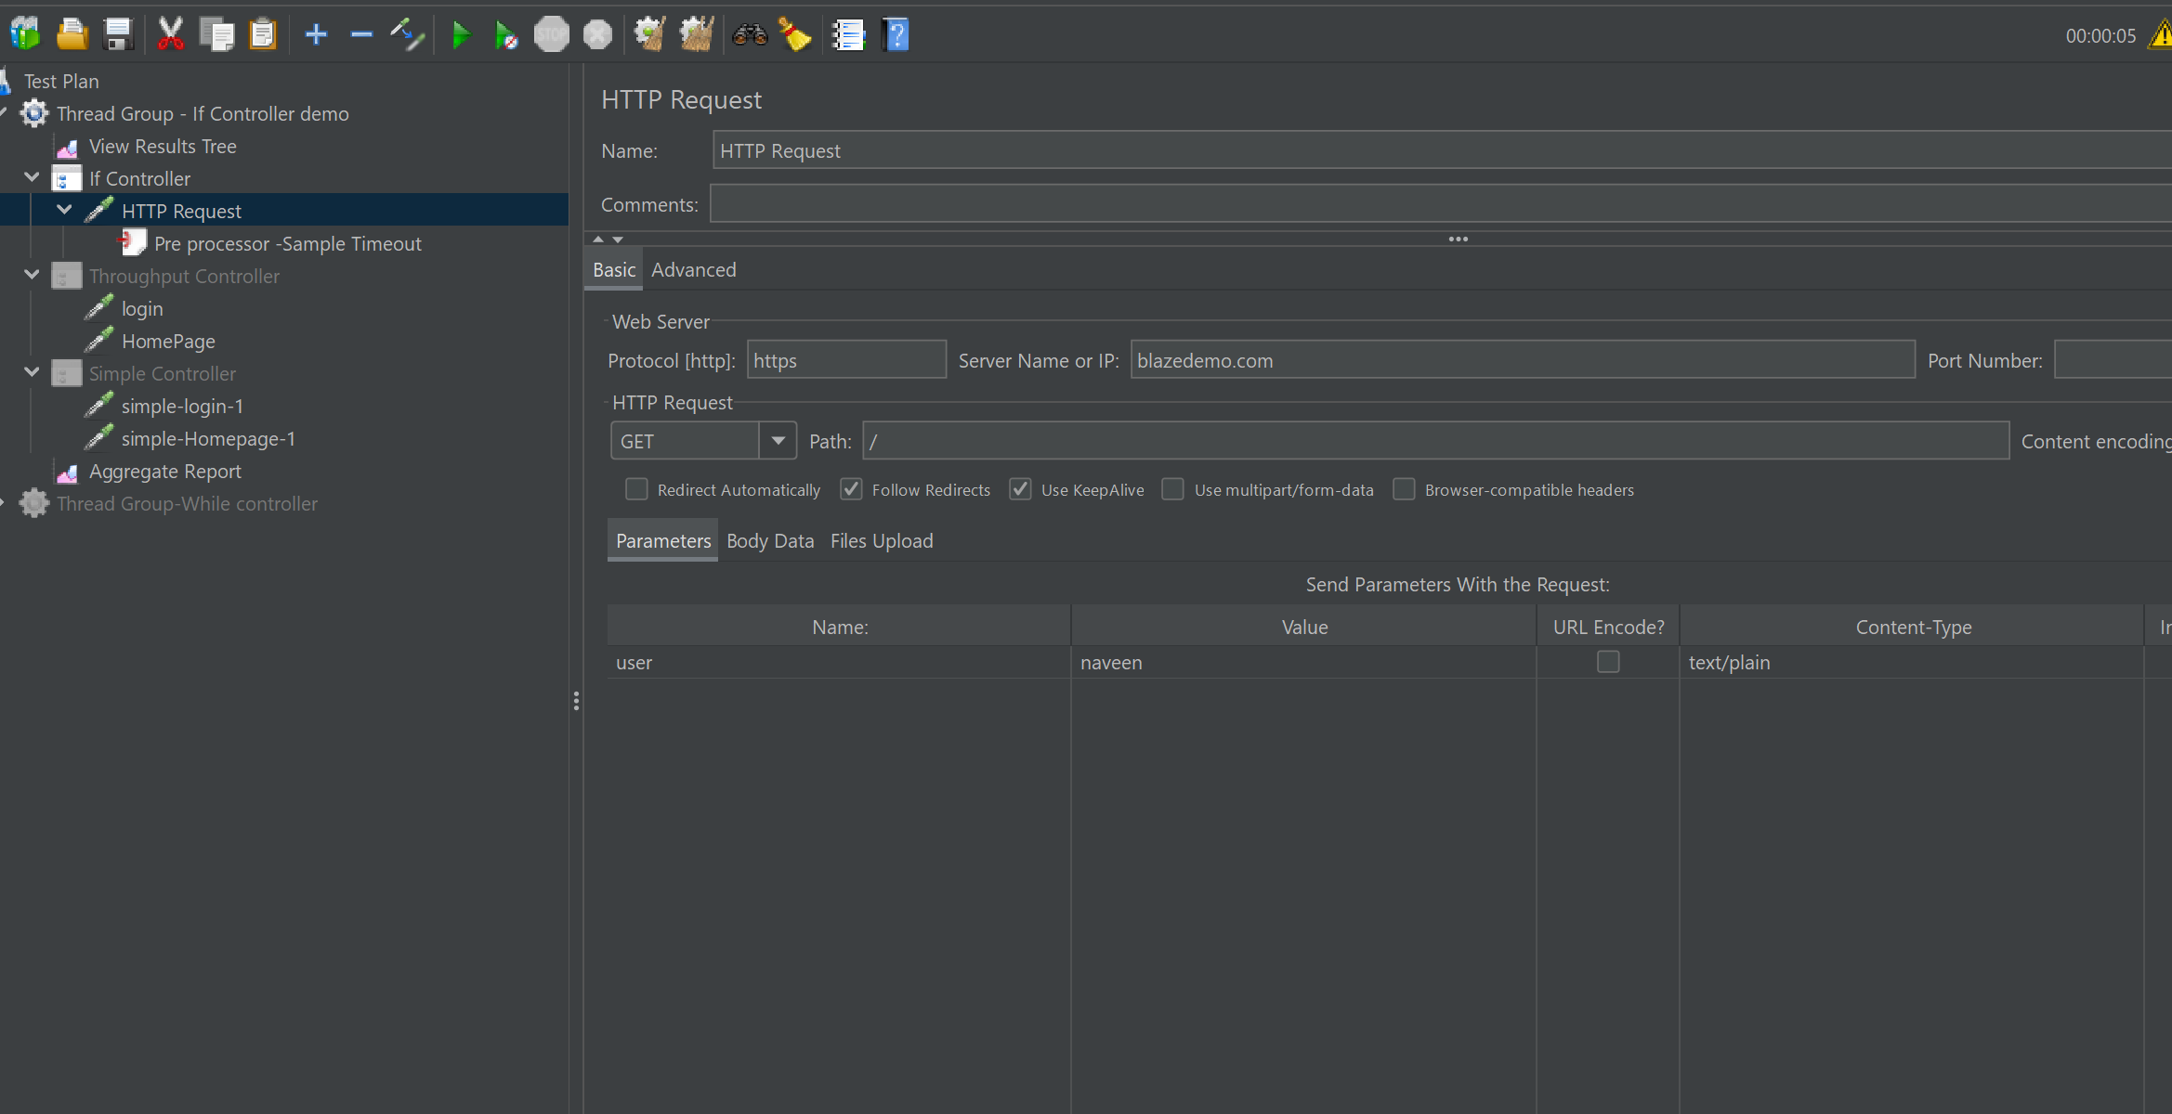

Sample Timout given 2000 milliseconds for execution.

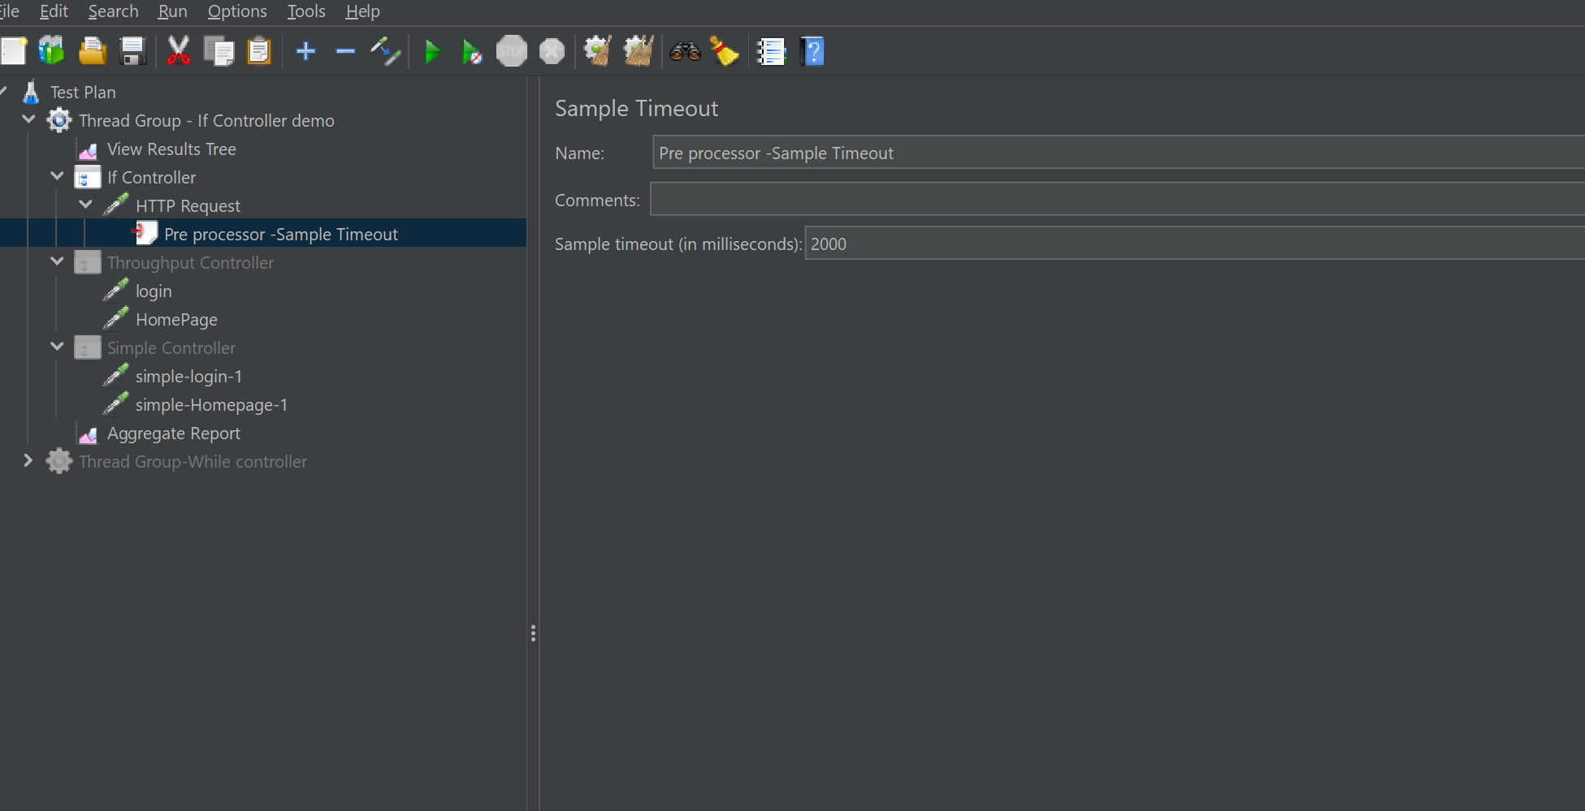

If controller used to check condition as shown below:

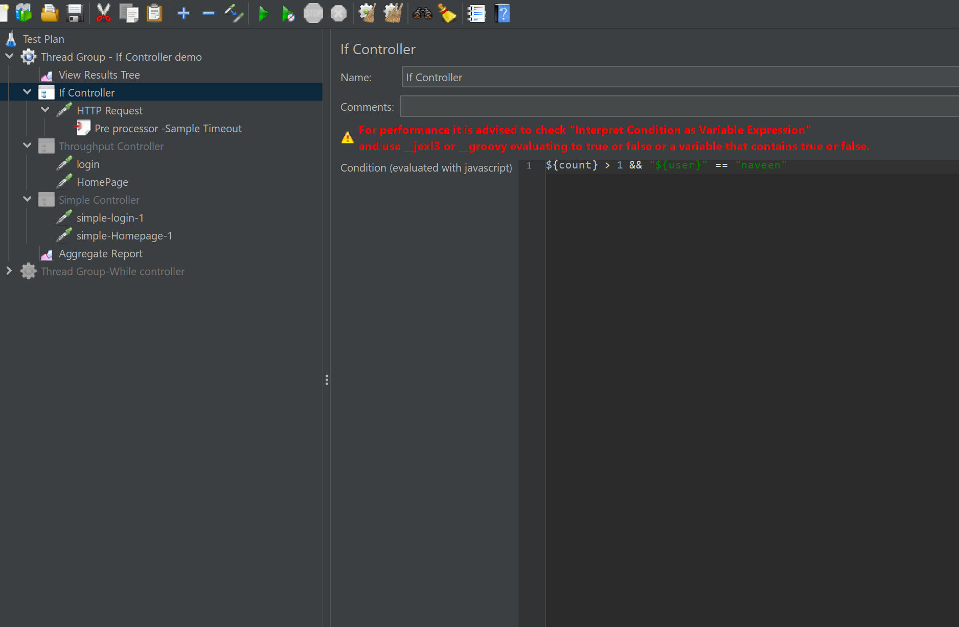

OUTPUT:

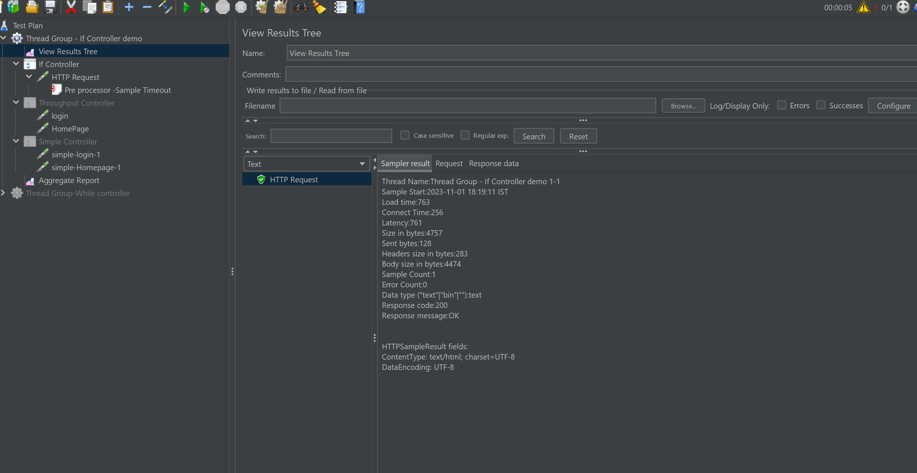

WHILE CONTROLLER

**Checks for the condition to execute the test**

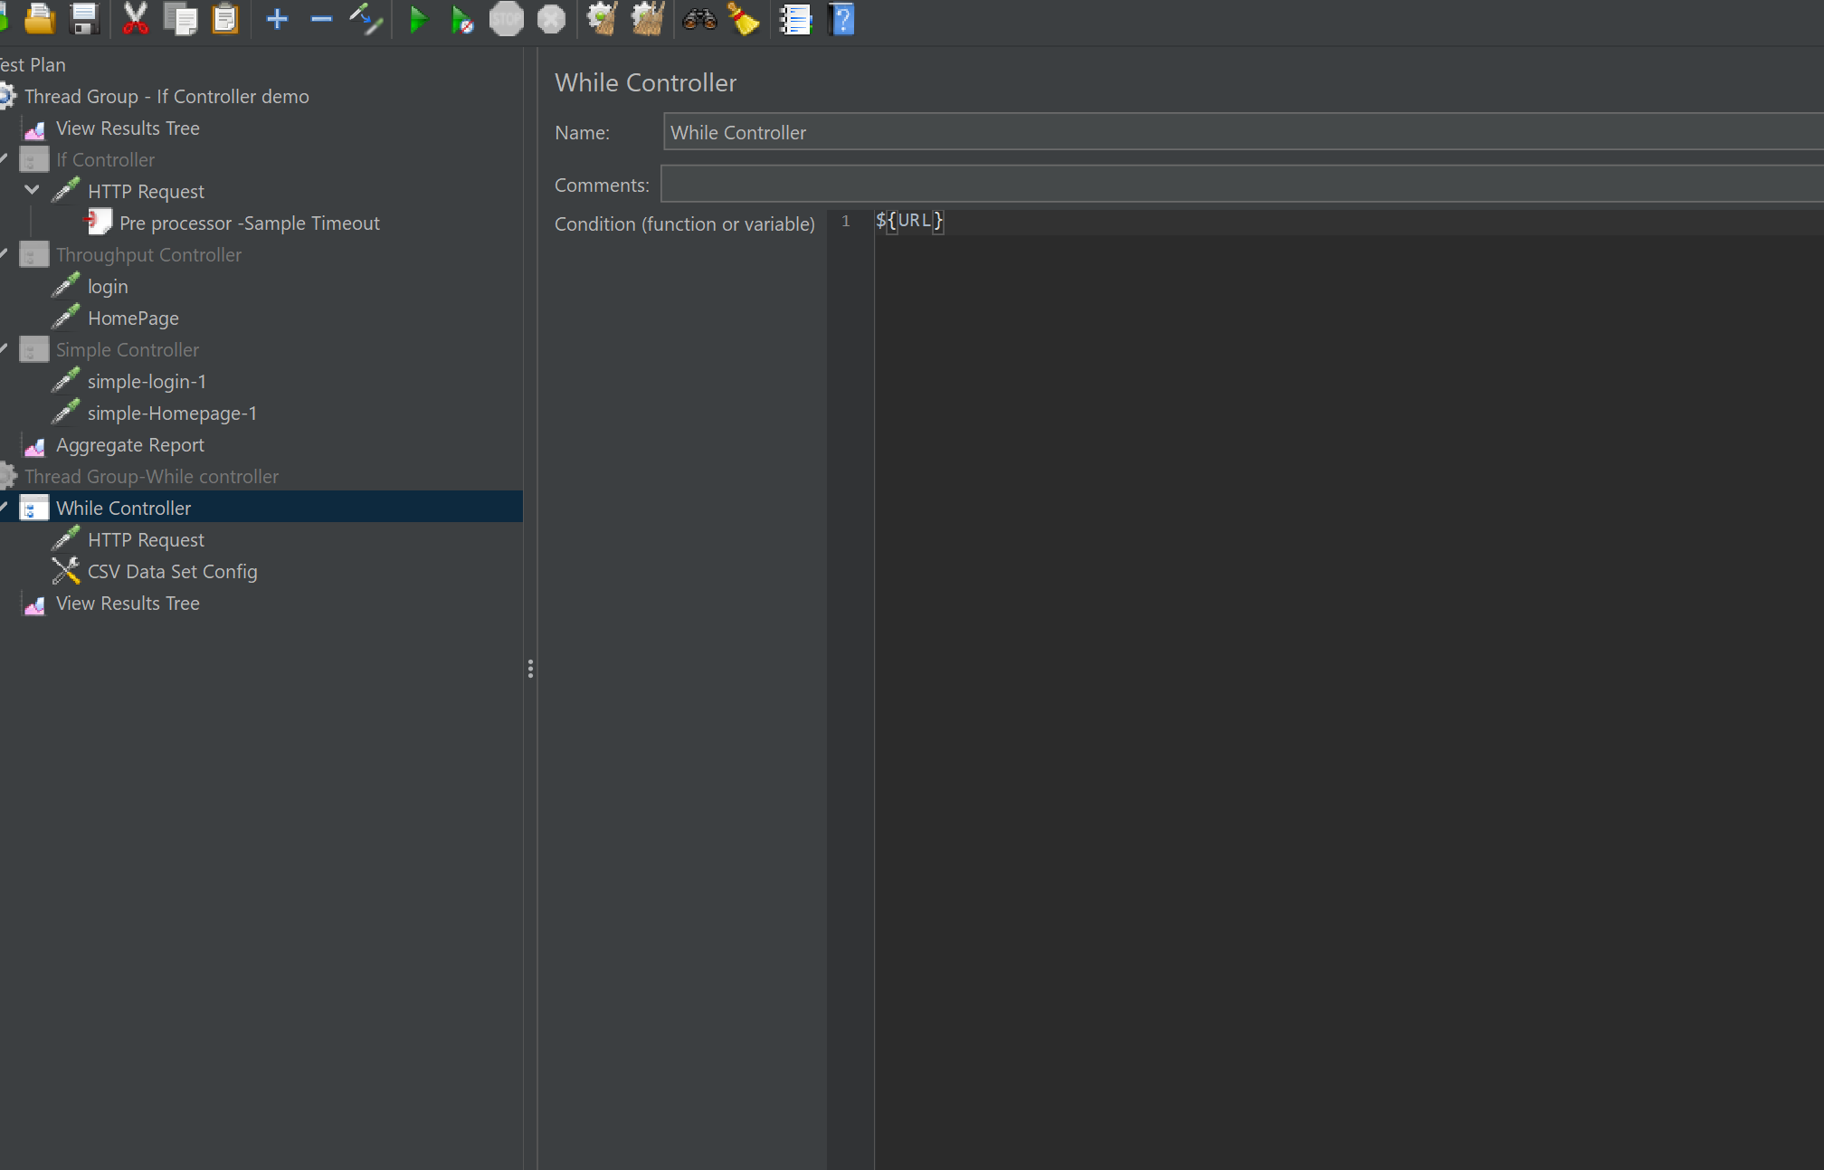

BELOW CSV –give the correct details for while controller execution.

